Allergens: Chef Recipe Cards

Dish Name: Dall Mash
Serving: 150g (170 Kcal) 44min of Walking)
Ingredient: Dall Mash - Cooking Oil- Onion Seeds – Fennel Seeds- Whole Cumin-Garlic – Ginger- Tomato – Chili Powder – Black Pepper Powder – Salt - Coriander Powder Turmeric Powder – Chili Powder– Fresh Coriander for Topping

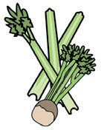  Celery | 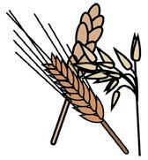  Cereals containing gluten* | 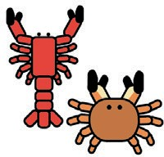  Crustaceans  + |   Eggs |   Fish
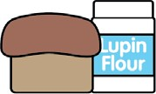  Lupin | 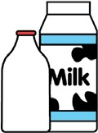  Milk |   Molluscs | 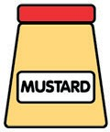  Mustard | 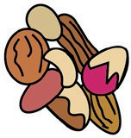  Nuts
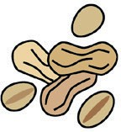  Peanuts | 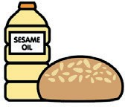  Sesame seeds | 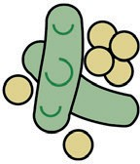  Soya |   Sulphur dioxide | Tick the allergens which are in the dish

Allergens Contain: Free of Allergen
Notes: It Is High in Protein and Fiber Dall Mash (Urid Dal Or Split Black Lentils) Is A Legume, And While Not Considered A Top-8 Common Allergen, It Can Still Trigger Reactions in Sensitive Individuals.
Reviewed and checked by: _______________
Executive Chef

